# Nested Simple Subqueries

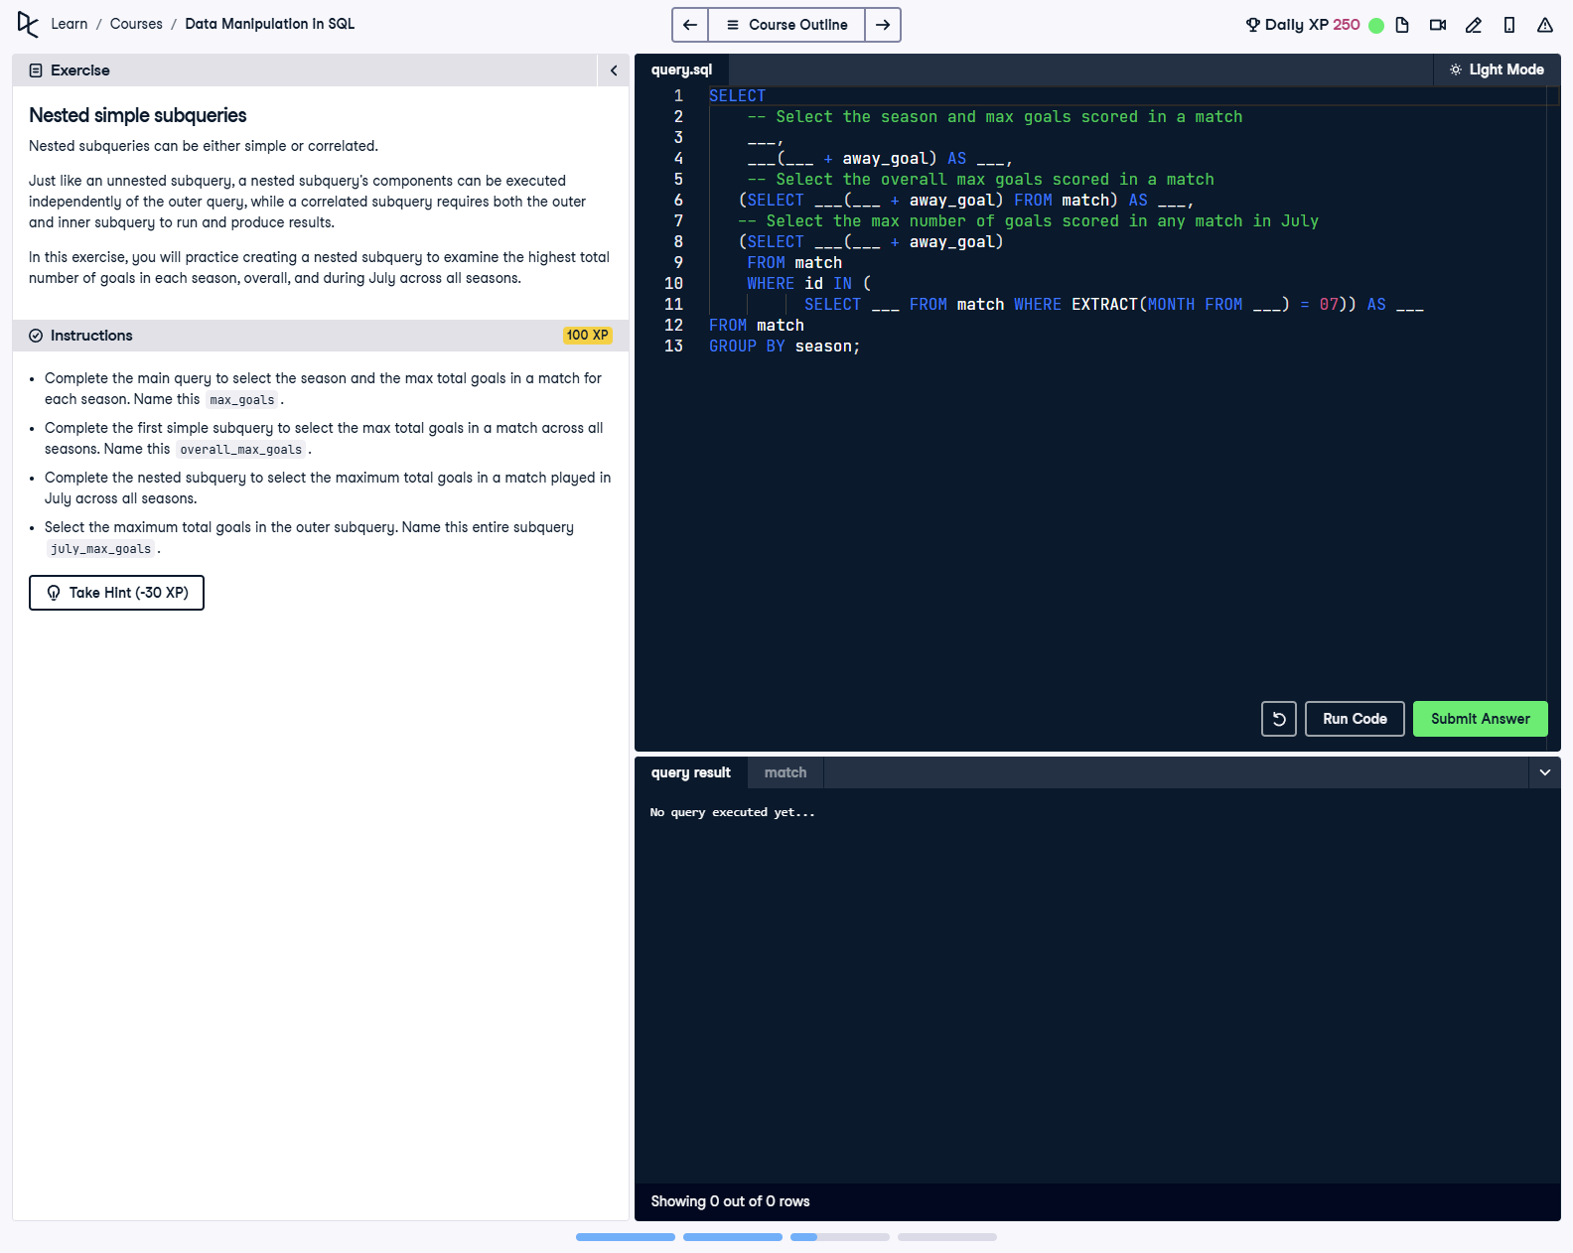

## Question

1. Complete the main query to select the season and the max total goals in a match for each season. Name this max_goals.  
  
2. Complete the first simple subquery to select the max total goals in a match across all seasons. Name this overall_max_goals.  
  
3. Complete the nested subquery to select the maximum total goals in a match played in July across all seasons.  
  
4. Select the maximum total goals in the outer subquery. Name this entire subquery july_max_goals.

## Corrected Solution

SELECT  
 -- Select the season and max goals scored in a match  
 season,  
 MAX(home_goal + away_goal) AS max_goals,  
 -- Select the overall max goals scored in a match  
 (SELECT MAX(home_goal + away_goal) FROM match) AS overall_max_goals,  
 -- Select the max number of goals scored in any match in July  
 (SELECT MAX(home_goal + away_goal)  
 FROM match  
 WHERE id IN (  
 SELECT id  
 FROM match  
 WHERE EXTRACT(MONTH FROM date) = 7  
 )) AS july_max_goals  
FROM match  
GROUP BY season;

## Explanation

This query identifies the highest total goals scored in each season, the overall highest goals in a match across all seasons, and the highest total goals scored in matches played in July. It uses nested and simple subqueries to calculate these values. The main query groups the data by season to analyze seasonal statistics, while the subqueries handle overall and specific cases.